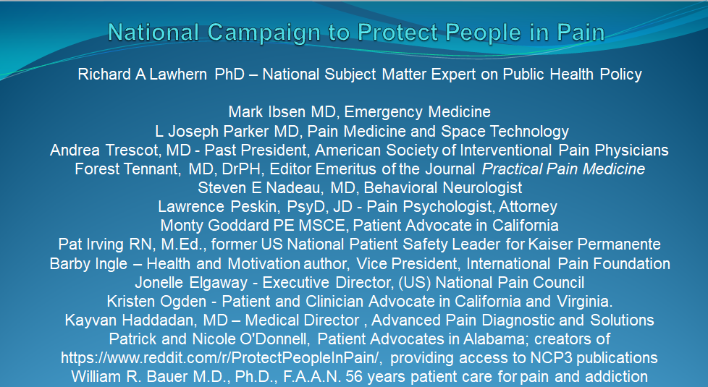
NCP3 QUARTERLY REPORT 2025-Q3
This note reports on activities and accomplishments of the US National Campaign to Protect People in Pain (NCP3) for the third calendar quarter of 2025.
We are an all-volunteer organization of over 1,200 practicing clinicians, patient advocates, healthcare writers, editors, reporters, lawyers and patients. Our mission is to advocate for major changes in US public health policy for management of pain and addiction. Membership is free, and member names are kept confidential in our mailings unless members have given explicit permission to make theirs public.
PUBLICATIONS AND CONFERENCES
A paper by Larry Aubry and Dr. Lawhern in the Medical Research Archives of the European Society of Medicine is getting significant attention as a follow-up to a 2021 paper by Aubry and L Thomas Carr.
https://esmed.org/MRA/mra/article/view/6539/99193549129
Relationship between Patients Dispensed Prescription Opioids, Opioid
Treatment Admissions and Overdose Deaths: 2006 - 2018 and Beyond

Dr. Lawhern also published “Why Chronic Pain Patients and Doctors are both Under Attack", KevinMD, August 21, 2025 . https://kevinmd.com/2025/08/why-chronic-pain-patients-and-doctors-are-both-under-attack.html
Dr. Lawhern, Pat Irving and Monty Goddard of the NCP3 Speakers Bureau participated in a landmark FDA conference on forecasting demand for Schedule 1 and Schedule 2 controlled substances (August 27, 2025). A paper summarizing their three-minute presentations in public comments was published by a mainstream peer-reviewed clinical journal, and has been incorporated into the conference minutes:
Richard A. Lawhern PhD, “The FDA is Talking When They Should Be Listening – Part 2”, AJMCRR. 2025;4(9): 1-3. 05 September 2025, https://ajmcrr.com/index.php/pub/article/view/347/355
Dr. Lawhern’s presentation began with a direct confrontation of members of the FDA panel:
“I would assert that members of this FDA panel are in fact accessories to one of the largest healthcare frauds in US history. They are also entirely aware of what I am about to say because I and my colleagues briefed them in July 2024”.
Dr. Lawhern PhD, Mark Ibsen MD, and Neil Anand MD, have also submitted “The Fatal Flaws of NarxCare AI: What Mark Twain Would Say About Predictive Medicine” to multiple publication venues including IPain, the journal of the International Pain Association, and World Journal of Pharmaceutical and Medical Research (ISSN 2455-3301)

An additional paper has been approved and will shortly be published in KevinMD: working title, “Let’s Hang All the Lawyers!”

TRAINING FOR PATIENTS … AND DOCTORS
The Alliance continues in efforts to inform and educate patients, doctors and policy makers concerning the need for major redirection of public health policy on management of chronic pain and/or addiction. We continue to build membership in a sub-Reddit interest group called “Protect People in Pain”. Six months after founding this forum, it had expanded to 430+ members, among the top 30% of all forums on the platform.
[ https://www.reddit.com/r/ProtectPeopleInPain ]
We have also published an online training course for patients, clinicians, and others who are considering participation as State Leaders of our National Campaign. This one-hour video/audio presentation addresses the process of “Lobbying State Boards” of medicine, pharmacy, and nursing. All are welcome:
https://drive.google.com/file/d/1x-qtVGsfjt4eYSMP-I9zbIZt06yp4Hli/view?ts=681229bf
In a major breakthrough for people in pain, Dr. Lawhern was invited by HealthHIV, a harms reduction group active in the Washington DC area and funded by the DC Department of Health, to develop a course in continuing medical education for doctors, nurses and pharmacists. The course identifies major errors of science and fact that were incorporated into the US CDC and Veterans Administration 2022 guidelines on prescription of opioids. The course has been formally accredited by the Postgraduate Institute for Medicine and is available free online here:
https://ehealthhiv.org/course/view.php?id=609
The course is funded in part by the Government of the US District of Columbia, DC Health, HIV/AIDS, Hepatitis, STD and TB Administration (HAHSTA). This offering was planned and implemented by the Postgraduate Institute for Medicine and HealthHIV. The Postgraduate Institute for Medicine is jointly accredited by the Accreditation Council for Pharmacy Education (ACCME), the Accreditation Council for Pharmacy Education (ACPE), and the American Nurses Credentialing Center (ANCC).
This activity provides 1.5 CME credits for physicians, nurses, pharmacists, Physician Assistants, and Social Workers. You must register with HealthHIV to take the course but it is open to patients themselves who do not wish to apply for CME credit. NCP3 is widely and repeatedly announcing the course in online forums read by healthcare professionals.
A second CME course was published in July to train clinicians, nurses, and others on the recommendations of the 2023 Consensus Guidelines of the American Society for Interventional Pain Physicians (ASIPP). This CME is also accredited by the Institute for Postgraduate Medicine. An important credibility builder for this CME is that peer review is being provided by Dr. Andrea Trescot, a past President of ASIPP.
https://reduceharmdc.org/training/guidelines-for-opioids-for-chronic-non-cancer-pain/?eType=EmailBlastContent&eId=1ad4b68a-0e25-444f-b21e-efcf1f62d259
HealthHIV has also invited Dr. Lawhern to submit an abstract and develop a presentation for their major conference, titled SYNC2025, in Rosslyn VA in March 2026. Conference attendees will include both clinicians and key decision makers from State and Federal Agencies. The presentation draws heavily upon material from the CME courses noted above, as well as a seminal paper published in December 2024 by the Clinical Medicine and Health Research Journal:
https://cmhrj.com/index.php/cmhrj/article/view/410/246
Conference organizers are investigating setting aside discussion space for presentation attendees, to further explore the references and evidence that supports the conclusion of the presentation: that the US CDC, VA, DEA and DoJ have committed healthcare fraud and are responsible for thousands of negligent homicides that are a direct outcome of their policies restricting availability of safe and effective prescription opioid analgesics.
Dr. Lawhern has also circulated announcements of both CME courses outlined above, to over 15 US National organizations responsible for Board Certification of clinicians in multiple specialties who treat pain and addiction. This announcement has been posted to Linked In newsgroups serving registered readerships of over two million healthcare professionals. The announcement will be repeated periodically.
PENDING STATE BOARD ACTIONS
Richard A Lawhern PhD submitted a formal complaint in March 2025 to the Maine Board of Licensure in Medicine, against Noah Nessin MD, a member of that Board and a key influencer active in multiple legislative forums in that State. Grounds for this complaint were that Dr. Nesin advocates for and trains doctors to conduct a program of forced tapering of opioid analgesic medications of all patients who have been managed on this class of pain relieving medications; the substantive content of his education programs for other clinicians is both fatally flawed on science and actively abusive of patients.
This formal complaint was considered in the May 13th meeting of the Maine Board of Medical Licensure. However, the Board chose to reject the complaint without substantively addressing its basis. In consequence, Dr. Lawhern filed a formal 22-page complaint on June 4, 2025 against all sitting members of the Board with the Office of the Governor of Maine, asking that an investigation be conducted to evaluate whether all sitting Board members should be fired for cause and replaced. This complaint has been endorsed by over 100 patients, caregivers, and clinicians from across the US. In the third calendar quarter, we will demand that the Maine Attorney General investigate the Office of the Governor for violation of State laws pertaining to required responses to public complaints. Thus far, the Office of the Governor has not responded to our complaint. As a result, Dr. Lawhern has alerted the membership of the Maine Senate Health and Human Services Committee, to the effect that the Office of the Governor may be in active violation of Maine state laws on transparency. Thus far, the Maine legislature has been pointedly silent on this input. Two Maine newspapers have likewise refused to rise to the bait.
We haven’t given up on this initiative. But it appears we will have to solicit involvement by major investigative reporters in Nationally distributed newspapers.
=====
Dr. Lawhern and Jonelle Elgaway continue their efforts in social media to contact patients who have been harmed by forced tapers or doctor desertion. So far, just over 120 people have responded. Some of their email addresses are listed as potential endorsements of our complaint before the Maine Board of Licensure in Medicine.
Jonelle has likewise been invited to speak in multiple US and international conferences in which her patient advocacy as a member of our Alliance Speakers Bureau will be a key element of her presentations. Her social media video clips are very effective on Tik Tok, Facebook, and other platforms.
ADVOCATES MEETING HOUSE
In May 2025, the National Campaign broadly announced an outreach effort to support group moderators and administrators throughout chronic pain communities. Each group was invited to share an email contact address to facilitate rapid dissemination of key information throughout these communities. Thus far, 23 groups in the US and Canada have signed on, representing tens of thousands of US and Canadian patients, caregivers, and clinicians. The same announcement and invitation is being posted multiple times to Linked-In newsgroups that serve over two million Healthcare Industry professionals (doctors, nurses, pharmacists, mental health change agents, hospital administrators and industry organizations).
This outreach effort has already born fruit.
STATE BOARD INITIATIVE
Pat Irving, RN, MEd, healthcare writer and a member of the NCP3 Speakers Bureau, has been leading a major initiative to influence state medical and pharmacy boards to take a more evidenced based approach to their Opioid Prescribing Guidelines and Rules. Many state board guidelines still include MME limits and are silent on the question of force tapering patients. This initiative also supports patients who have been harmed by bias or ineffective opioid prescribing rules to compose and deliver their complaints to the board. A final, but critical focus of this initiative is to support physicians who have been unjustly targeted by their boards for prescribing pain medications well within the standard of care.
There are already members of this initiative working in several states. Kristen Ogden, Pat Irving, and Monty Goddard of the NCP3 Speakers Bureau are engaged in ongoing discussions with staff and members of the Medical Board of California (MBC) and the California Board of Pharmacy (CBOP). MBC officials have committed to expanding outreach efforts by the Board to educate all stakeholders to the significantly reduced barriers to pain treatment that are incorporated in the MBC’s 2023 California Guidelines for Prescribing Controlled Substances for Pain. Additionally, they are working jointly with the MBC and the CBOP to address the harm to patients which has resulted from the state AGs’ nationwide opioid settlement’s injunctive relief provisions. This effort includes encouraging the boards to ensure the California Department of Consumer Affairs and the Offices of the California AG and Governor are made aware of this ongoing harm.
If you are interested in joining the State Board Initiative, please contact Pat Irving at dirving@sonic.net. Support for members include a series of presentations designed to provide advocates the skills and strategies needed to engage in person-to-person advocacy with their boards. There is also a monthly “Advocacy Session” given by Pat Irving on DocToks hosted by Dr. Forest Tennant and Jaime Sanchez.
Thousands of voices are needed, speaking in concert.
see https://www.youtube.com/watch?v=JtxewBbLrfw
The tide is changing on US public health policy for pain management employing prescription opioids. In the not too distant future, large numbers of government bureaucrats and financially self-interested “influencers” in organizations like PROP may find themselves looking for a more honest line of work – some of them from the inside of a Federal Correctional Facility.

