National Campaign to Protect People in Pain
Progress Report
February 12, 2026
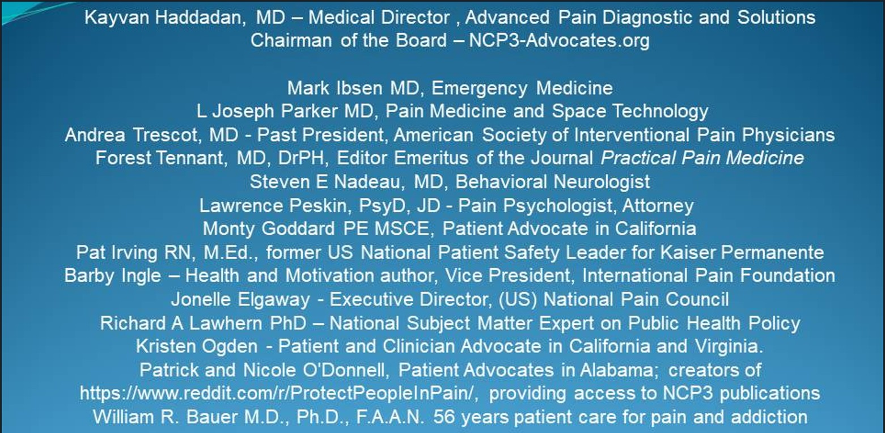
This progress report summarizes advocacy and education work performed on behalf of US and international pain patients and their clinicians (doctors, nurses, nurse practitioners, and others licensed to treat pain) during the first six weeks of 2026. This report will be distributed to US and State healthcare officials, and shared with social media newsgroups serving over two million healthcare professionals.
Among officials placed on notice by this progress report are the following. Other readers should feel free to employ these email addresses in their own commentaries and demands for change in US healthcare policy:

First Name | Last Name | Email Address
CDC | Office of Executive Secretary | cdcexecsec@cdc.gov
Listening Session | FDA | CDERPASE@fda.hhs.gov
CDC | Customer Support | cwus@cdc.gov
Public Affairs Office | US DEA | DEA.public.affairs@dea.gov
Diana | Perez-Rivera (CMS) | Diana.perez-rivera@cms.hhs.gov
Assistant Sec Planning | DHHS | epaedeareport@hhs.gov
CDC | Injury Center | injurycenter@cdc.gov
Jennifer | Hobin (Ch of Staff, US NIDA) | jennifer.hobin@nih.gov
Kimberly | Compton (FDA) | kimberly.compton@fda.hhs.gov
Board of Science Advisors | CDC/NCIPC | ncipcbsc@cdc.gov
Nora | Volkow | nvolkow@nida.nih.gov
Office of Civil Rights | DHHS | OCRMail@hhs.gov
Claire | Brennan (DEA) | odlp@dea.gov
Office Scientific Integrity | CDC | scientificintegrity@cdc.gov
Doctors and Patients should feel free to employ these email addresses in their own commentaries and demands for major change in US healthcare policy:
Leadership Transition
Our National Campaign is pleased to announce that Kayvan Haddadan MD has agreed to take over as Chairman for our Speakers Bureau. He brings to this position, 20 years of publications in multiple areas of pain medicine and other fields. He likewise brings a wealth of technical support for our expanding online activities in advocacy. See https://kevinmd.com/post-author/kayvan-haddadan
Richard A Lawhern PhD has transitioned into Emeritus status as co-founder of the National Campaign. He will continue to support the Campaign as a clinical educator and writer in multiple online venues, and as one of our site administrators for our newly created website.
https://ncp3-advocates.org/
Publication Activities
The National Campaign continues to gain traction and visibility with multiple wide-ranging publications. We are focusing attention on the profound misdirection of US national public health policy and the many outright frauds perpetrated by US healthcare agencies affecting the mistreatment of severe chronic pain and addiction.
The message to Agency heads and senior staff in DHHS and DoJ is clear: we are coming for you, and it’s time for you to either engage with our program or get out of Dodge! If you continue to refuse to correct course, you will be investigated, indicted, tried, convicted and sent to prison for your roles in the negligent homicides of thousands of suffering patients, and the malicious and unfounded prosecutions of hundreds of blameless clinicians.
Among our key publications are:
The Blind Men and the Elephant: A Parable for Modern Pain Management.
This paper has also been re-published by invitation of the editorial staff of: Life Science Daily News, to an international readership. We anticipate an ongoing mutual win-win relationship with this new publication venue, with monthly reprises on articles by National Campaign authors.
See (https://lifesciencedaily.news/the-blind-men-and-the-elephant-a-parable-for-modern-pain-management/)
A second paper published in January 2026 on KevinMD is “US Opioid Policy History – How Politics Replaced Science in Pain Care.”
A third and very powerful personal narrative by Monty Goddard paints a wrenching picture of the evil consequences of public health agency misdirection and misinformation: My Wife’s Story – How DEA and CDC Guidelines Destroyed Our Golden Years.
State Board Initiatives
Pat Irving RN and Monty Goddard continue to lead activities of the National Campaign to lobby State Boards of Medicine and Pharmacy for major improvements in clinician education and State laws governing prescription of opioid analgesics. They led participation by several highly effective patient advocates in an all-day January meeting of the California State Board of Pharmacy and several stakeholder groups, including the office of the Attorney General.
They successfully presented the message that incremental improvements in written policies of the State Boards are “too little, too late” to save the lives of thousands of California patients in agony. California clinicians do not believe statements by their own Boards that they will not be prosecuted for treating pain by any means necessary.
See Pharmacy Board Review
National Campaign Training
The National Campaign is conducting a series of free online one-hour seminars on “Using Search Engines without Encountering the GIGO Law”. The first half of each seminar is a formal presentation illustrating the errors that can result from biased or inaccurate literature that is reviewed and curated by Artificial Intelligence-based search engines. Methods for identifying bias and correcting it are illustrated for a key issue of clinical practice. These methods can be extended to other fields.
The second half of these seminars allows attendees to explore capabilities of a highly capable search engine in real time, for subjects of their choosing.
To be placed on an invitation list for future seminars, send email to Lawhern@hotmail.com Both new and repeat attendees are welcome.
‘Pending Activities of the National Campaign
Jonelle Elgaway of the National Campaign will shortly file papers of incorporation for our National Campaign, as a 501(C) 4 Nonprofit Organization in North Carolina. By-Laws have been written under the laws of that State. She will request a Federal Employer Identification Number and establish a checking account for contributions from our membership. These contributions will never be disbursed for purposes other than reimbursing expenses of the Campaign in creating or administering its websites and sending representatives to conferences and meetings.
Richard A (Red) Lawhern is scheduled to address a session at a Harms Reduction conference on Wednesday March 18, 2026 in Rosslyn Virginia. See https://syncconference.org/tracks/
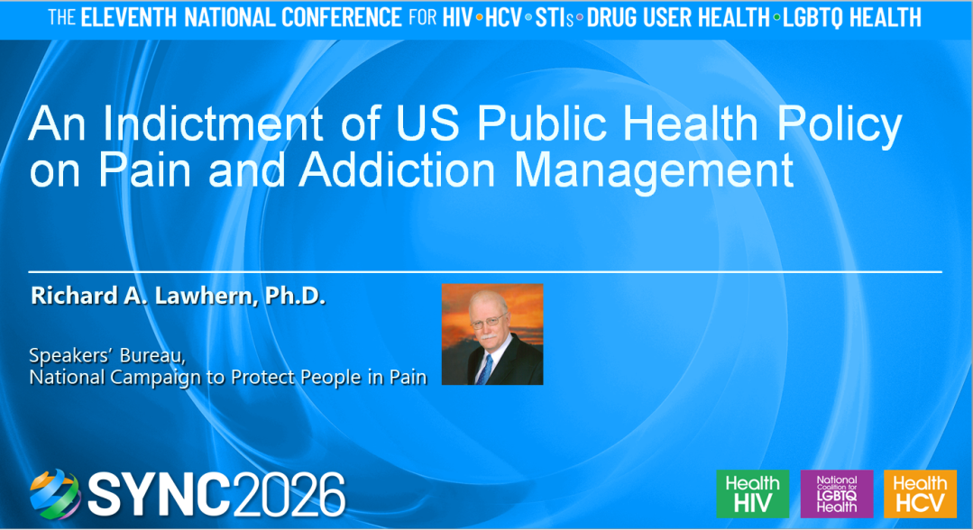.
This 20-minute presentation will approach “harms reduction” from a very much different perspective than other work offered at the conference. Based on papers published in clinical literature and CME courses sponsored by the conference hosts, Dr Lawhern will offer conclusive evidence that US healthcare Agency heads and senior staff are guilty of having perpetrated the largest and most destructive healthcare fraud in US history -- resulting in the deaths by negligent homicide of thousands of US pain patients and the destruction of the practice of American pain medicine
Recruitment
Your National Campaign is engaged in ongoing recruitment activities on multiple social media platforms, including Facebook, Linked-In and others. We invite clinicians, knowledgeable patients, support group moderators, family caregivers, journalists and editors to take ownership of advocacy and the need for major changes in public health policy. We will train such volunteers to:
- Lobby State Boards
- Educate and lobby State and Federal legislators by in-person presentations at District offices and State Capitals
- Write or speak in public media
Our objective is nothing less than changing the entire public conversation concerning treatment of pain and addiction, at all levels of government and among clinical professional organizations. We seek to implement the meme:
Nothing About Us Without US


